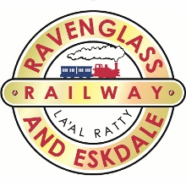
Medida Holidays Accessibility Statement
For the Ravenglass & Eskdale Railway
Introduction

One of the Lakeland’s hidden treasures. Take a journey on one of the oldest, longest, narrow gauge railways in the world. The railway provides the perfect opportunity to combine a steam journey with plenty of trails and walks to discover this part of the Lake District National Park.
- A collection of four steam locomotives in regular service with open and closed carriages
- The main station is at Ravenglass, with a terminus at Dalegarth & intermediate stations
- Easy accessible wide pathway leading from car park to booking office and other facilities
- Disabled toilet on main platform and on first floor of the cafe (lift available)
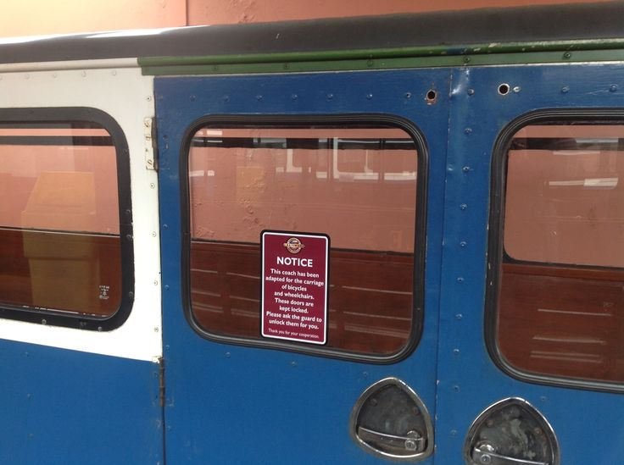
- Cafe and tearoom with movable seating and tables, plus high chairs
- Accessible outdoor seating area with picnic benches
- Gift shop, information room with TV presentation and a museum
- Accessible grass area with seating
- Children’s play area with seating
- Large car park, with disabled parking spaces by main entrance + coach parking
- Wheelchair available if required
- Motorised chairs and mobility scooters are allowed onto the platforms
- Service and guide dogs welcome all areas
- Wheelchair adapted carriages – call to book in advance
The terminus station at Dalegarth has all the main facilities, featured later, but intermediate stations are basic and limited. We would recommend that guests join and alight at each end of the line.

The staff are helpful, friendly, welcoming and are pleased to assist with any enquiries.
Pre- arrival
A clearly worded leaflet is available describing the engines with photos, a map and points of interest on the line, departure times and prices, main facilities, local attractions, diary dates and directions. The leaflet includes contact numbers, email and website addresses. The leaflet is widely distributed to other tourist venues, hotels, guest houses, caravan parks and Tourist Information Centres.
The leaflet also includes:
- Group packages & bespoke interest tours available on request
- Special events
- Santa Express
- “Rail and Sail”- Cruise and Ride joint tour with Ullswater Steamers & Ravenglass railway
- Language packs (French-German-Japanese-Dutch-Spanish-Chinese) available
- All the above information can be found on:
Website: www.ravenglasss-railway.co.uk or email: steam@ravenglass-railway.co.uk
- Video of the attraction https://www.youtube.com/watch?v=AFttcJKg_SI&feature=player_embedded
- Pinterest gallery of access focused images https://www.pinterest.com/lakedistrictest/accessibility-at-the-attractions/
Getting there:
Full, clear, key, coloured directions to Ravenglass from the M6 motorway at J40 (to Cockermouth) and J36 ( to Broughton) approximately a 60 minutes journey. Directions to Dalegarth station also available and all information is shown on both the website and in the leaflet.
Public Transport
Rail links
Ravenglass station is served by Northern Rail from Carlisle, Whitehaven, Maryport and Grange over-Sands, Monday to Saturday. Carlisle links with Virgin Rail direct from London, Glasgow, Edinburgh, Manchester and Birmingham and intermediate stations. There is also a link to Newcastle connecting with the East Coast mainline.
Arrival & Car Parking facilities
- Well sign posted from the A595
- Ravenglass station is a concealed turning on the left between the two railway bridges
- Car parking is Pay and Display
- Main car park has approximately 80 parking spaces
- Example charges as follows: £1.00 for one hour or £3.00 all day ( Allow 2 hours for round trip rail journey )
- There are 3 designated disabled parking spaces by main entrance to booking office
- Vehicles can be parked to allow rear access and there are no dropped kerbs
- Access to station is on tarmac and paving and is approximately 16 paces to booking office
- Large directional signs are located within the car parking area
- Free coach parking available at Ravenglass
- Ramped walkway from mainline Northern Rail platforms
- Charge point
- No queue policy in place if required
Main Entrance – (Booking office/Gift shop – Information room - Cafe - Museum)
Public Areas - General
- All public areas are located on the same level, with no steps to negotiate, allowing easy wheelchair access.
- Access to all areas is on tarmac/paving walkway 230cms width
- Mainly tarmac with some parking on gravel area
- Tarmac paths lead to booking office, platforms, cafe, information room and toilets
- Slight incline tarmac pathway leading to children’s play area with ample seating
- Access to grassed picnic area by cafe is via the play area through a gateway (110cms)
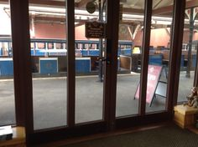
- Ladies and gents toilet plus disabled toilet and baby changing
- Large print café menus
- Audio app download and free wi-fi
- Allergen information in cafes
Booking office/Gift shop
- Tarmac level pathway from car park
- Double doors entrance (140cms)
- Wheelchair available from ticket office
- Open 9 to 6, (9 to 5 in low season) 7 days a week
- All items clearly priced; many at low level, staff will provide assistance if required
- Hearing loop
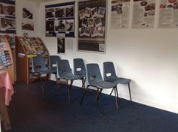
Information room
- Tarmac level pathway
- Easy level access, door width 95cms ( can be used as quiet space )
- Moveable seating
- TV visual information display & leaflet racking
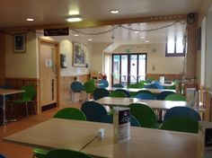
Cafe
- The Turntable cafe is located on the main platform area
- Tarmac level walkway
- Counter 90cms height
- Order meals at counter
- Moveable tables and chairs
- Good selection of light bites available
- Vegetarian and gluten free bread available
- Additional indoor seating upstairs, lift available, door width 120cms, steps to outside area
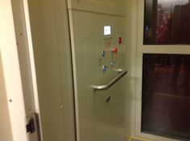
- Disabled toilet on this floor, door 95cms
- High chairs available
- Hearing loop
- Allergen information
- Free wi-fi
- Large/contrast print menu

Please ensure staff are made aware of any special requirements prior to ordering food
Museum – undergoing refurbishment so access information will be updated June 2015
- Located off main car park
- Entrance via designated ramp/walkway, width 180cms
- Main door access 130cms, internal access door 130cms,walkway door 85cms,walkway 78cms
- Circular indoor walkway
- Good lighting

Additional information
- Carriages – closed carriages door width 90cms & open carriages door width 120cms
- No smoking allowed – all areas
- Carer travels free with fare paying disabled passenger on production of a PIP or DLA certificate
- First Aid boxes carried on all trains and in shops
- A wheelchair is available at Ravenglass, subject to availability, ask at booking office
- Guide and service dogs welcome
- 40 minute train journey each way
- Adapted carriages – book in advance
Contact information
- Address: Ravenglass station, Ravenglass, Cumbria. CA18 1SW
- Telephone: 01229 717171
- Email: steam@ravenglass-railway.co.uk
- Website: www.ravenglass-railway.co.uk
- Follow on Facebook, Twitter, Google plus and Pinterest
- Website: cumbrianorthlancs.disabilityhelpdesk@stagecoachbus.com
- Northern Rail: www.northernrail.org
- National Rail Enquiries: 08457 48 49 50
- Travel Line – Public Transport Information – 0871 200 22 33
- Weatherline – 0844 846 2444
Dalegarth station
Dalegarth station is located approximately 14.2 kms from Ravenglass station off the A595. A map can be obtained from Ravenglass station. Directions are also shown on the promotional leaflet.
Arrival & Car Parking Facilities:
- Car parking on stones/gravel
- Clearly signposted from road.
- Disabled parking – (not designated) – park near entrance displaying Blue Badge
- Pay and Display car park – (not bayed)
- Charges as per Ravenglass. £1.00 first hour or £3.00 all day
- Space for approximately 60 cars
- 2 electric car charging points
- Coach parking
- Directional signage
Public Areas - General
- To access main platform exit car park up a ramped walkway onto tarmac area of main station
- Easy wheelchair access
- Children’s play area
- Picnic area
- Seating and outside eating area with moveable tables and chairs
- Ladies, gents and disabled toilet (door 95cms) on main platform
- Cafe, gift shop and additional downstairs seating with toilet facilities. No lift.
- No smoking allowed – all areas
Ticket office, cafe and gift shop
- All on one flat level
- Main entrance through double doors into ticket office
- Ticket counter 94cms
- Alternative entrance from platform into the Fellbites cafe (easy access through double doors)
- Moveable tables and chairs
- Counter 94cms
- Order meals at counter and delivered to table
- Same menu as Ravenglass station – also note extra choice on Specials Boards
- Additional seating down stairs, access via ramped walkway via car park, no lift
- Moveable tables and chairs
- Toilet facilities and baby changing
- Allergen information
- Large print menu
- Free wi-fi
- Audio commentary app

Updated 21/3/2015

